*Nightshade Academy* Design Document

This is meant to be mirrored from the Game Bible, I just hope it'll be easier for us to use as a to-do list and keep all the design stuff at hand.

# To-Do List:

Sprites can be made and animated in piskel (<https://www.piskelapp.com/>)

| Characters: | Backgrounds | Assets/Obtainable Items |
| --- | --- | --- |
| * ~~Main Character~~ ~~(tania)~~ * ~~Friend~~ ~~(bri)~~ * ~~Janitor~~ ~~(tania)~~ * ~~Headmistress~~ ~~(willow)~~ * ~~Lunch Lady~~ ~~(bri)~~ * ~~Homeroom~~ * ~~Chemistry~~ * ~~Math~~ * ~~Culinary (FACS)~~ * ~~PE~~ * ~~English~~ * ~~Student 1~~ * Student 2 * ~~Student 3~~ * Student 4 * Student 5 * Student 6 * ~~Teacher's pet~~ * ~~Senior~~ | * ~~Classroom(s)~~ * ~~Dorm Room~~ * ~~Hallway~~ * ~~Cafeteria~~ * ~~Janitor's Closet~~ * ~~Gym~~ * ~~Chemistry Lab~~ * Menu Screen | * ~~Desks~~ * ~~Books~~ * Trial assets * Music * ~~Chem lab stuff~~ * ~~Cafeteria tables~~ |

* 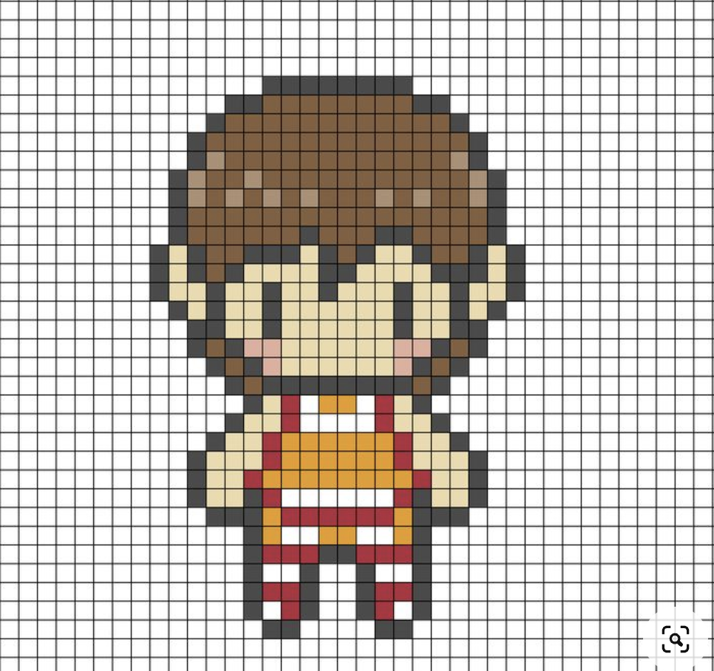

# References/Palettes/etc.

Uniform Inspo:  
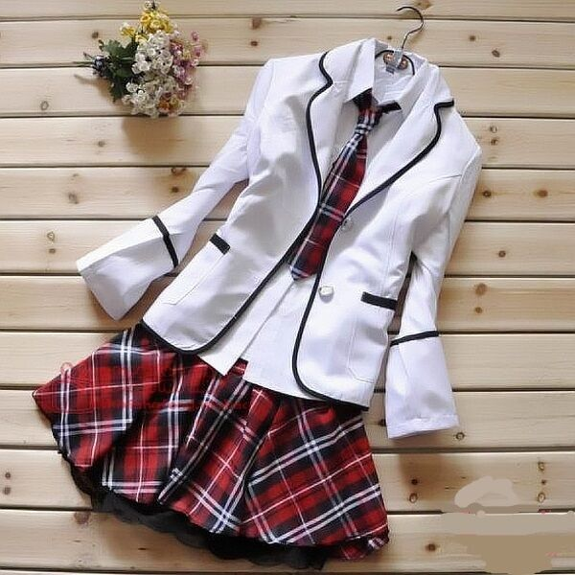  
Blazer: #ffffff  
Blazer Liner: #000000  
Pants: #7b2d28  
Shoes: #000

# Characters

* School uniform: white and red
  + White button-down, crimson pants
  + Red and white blazer

## **Main Character:** Jett/Player Input Name

* High schooler, ambiguous features
* Young, childlike, possible hallucination/memory issues, PTSD.

Normal/Mindless (the story doc said there's endings the MC can lose their mind in, idk if we want different sprites for that):  
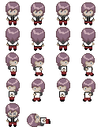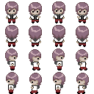

## **Janitor**: Mr. Yarrow

* Yarrow
* 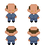

## Friend: Myo

* Myosotis (the scientific name of forget-me-nots)
* Died for the plot.
* 

## **Headmistress Moira Rouge**

* The perfect on the outside evil on the inside, mother-like.
* Warm and kind until someone breaks a rule, ruthless to those who break rules.
* Having grown up in a less fortunate family, she has climbed her way out using any means necessary. Many of her methods were less than savory. She refuses to let her hard work go to waste and uses her position to take advantage of families.
* Cultivates a garden of angel's trumpet flowers.
  + A highly poisonous and psychedelic plant.
  + Supplies it to the kitchen staff to mix into the food the students eat. There's just enough of the flower for the kids to get sick but not enough that they die.
    - "Oh the children are sick again, can you please spare some money so our nurse can get the medicine they need?" she'll plead to the parents.
* 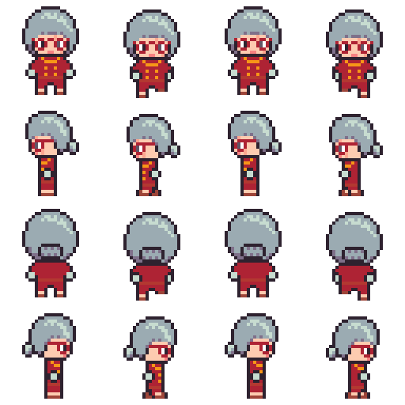

## **Lunch Lady: Ms. Da**ff

* Daffodil
* 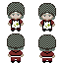

## **Teachers**

* **Homeroom Teacher:** Mr. Nettles
  + Dead-nettles
  + 
* **Math Teacher:** Ms. Fox
  + Foxglove
  + 
* **Chemistry Teacher:** Mr. Hemlock
  + Water hemlock
  + 
* **English Teacher:** Ms. Castor
  + Castor bean
  + 
* **Culinary Teacher:** Ms. Tansy
  + Tansy
  + 
* **PE Coach:** Coach Aconite
  + Aconite/wolfsbane
  + 

## Student**s**

* **Student 1:**
  + 
* **Student 2:**
* **Student 3:**
  + A kid with books could be a nerd for Math Quest
  + 
* **Student 4:**
  + Kid with art tools
* **Student 5:**
  + Kid with culinary tools
* **Student 6:**
  + Kid with bible
* **Student 7:** 
  + Kid with an animal corpse? Someone would have one
* **Teacher's Pet:**
  + 
* **The Nightshade Academy Team**
  + 
  + 
  + 
* **Senior**
  + 

# Backgrounds

640px by 360px

## Dorm Room

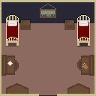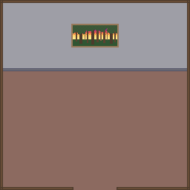

## Classroom

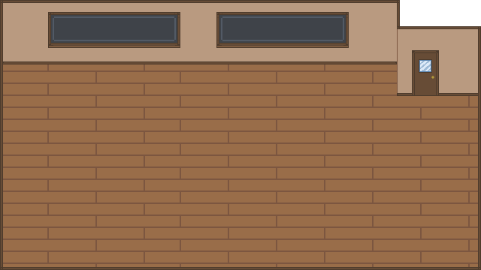

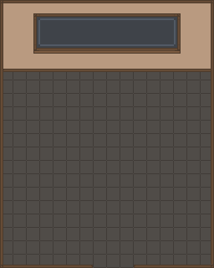

Hallway

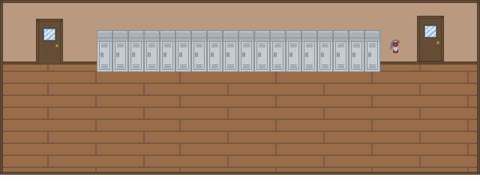

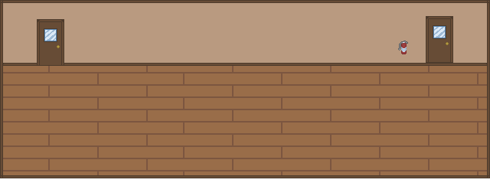

## Cafeteria

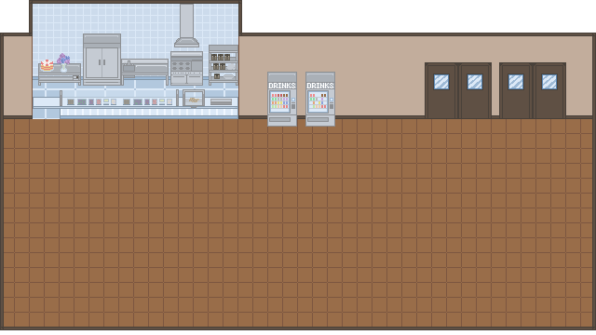

## Gym

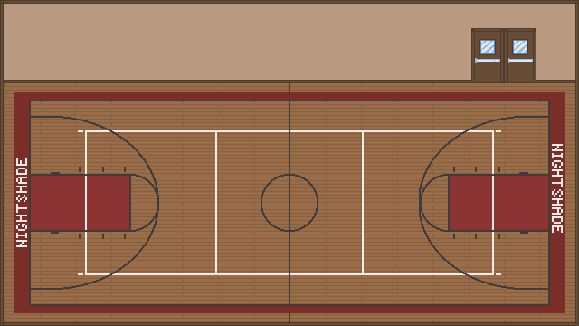

## Janitor's Closet

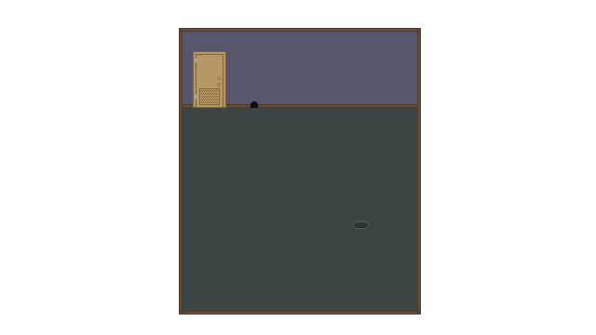

# Defunct Things We Don't Have to Make Anymore

**Security Guard: Mr. Ole**

* Oleander
* Blackmailed by the Principal, regretful about actions, able to be befriended.

**Nurse: Ms. Yew**

* European yew
* Similar to lunch lady ideas but less tough and intimidating more under-the-surface creepy.
* Motivation: Needed the money to survive so she has to go along with it.
* Nurse is doing research on how exotic plants affect the human immune system and they're using the children as guinea pigs before using it on adults.
* **History Teacher:** Dr. Belladonna
  + Belladonna
* **Biology Teacher:** Mrs. Pars
  + Cow parsnip
* **Religion Class Priest:** Father Rosa
  + Rosary pea
* **Art Teacher:** Ms. Lacey

Queen Anne’s lace

# Games we can take inspiration for sprite models

* Gameboy Pokemon games
  + Simplest backgrounds, sprites, and animations
  + 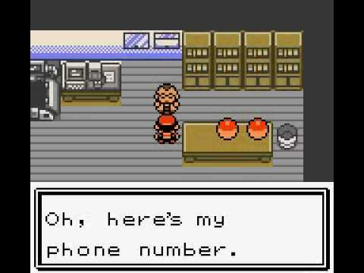
  + If we don't want to bother with doing full illustrations for dialogue we can keep them pixelated too
  + 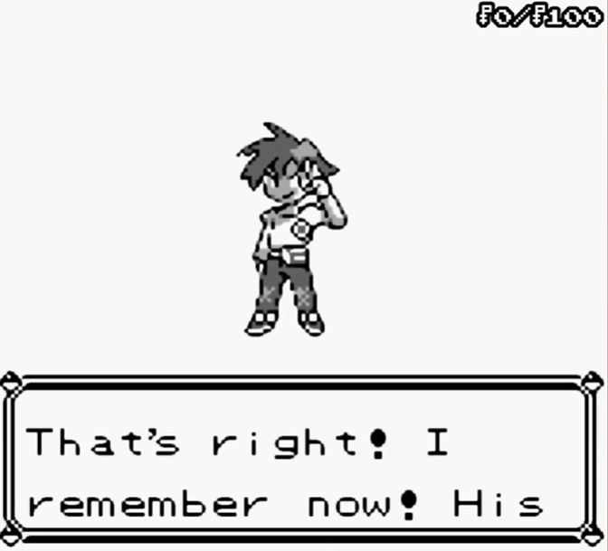
  + [Animation](https://youtu.be/pvH5hWc7Mes?si=86IUcd3K19zXOyg-&t=178)
  + [Dimensions](https://www.reddit.com/r/PokemonRMXP/comments/zb9lp8/what_are_the_dimensions_required_to_make_sprites/)  
    For overworld sprites you'll want 32x16 frames for GBA style, and 32x32 frames for DS era style. These will be formatted in a grid, four frames per row (the first frame should be standing, while the 2nd-4th frames should be animation for movement) and four total rows, each row being looking/moving down, right, left, and up respectively. Then you scale it up to twice the size you get.  
    For battle Trainer and Pokémon sprites, the sprite sizes generally are 80x80 for gens 3-4 and 96x96 for gen 5.
* Turnip Boy Commits Tax Evasion
  + Cutesy style
  + Simple but effective animations
  + 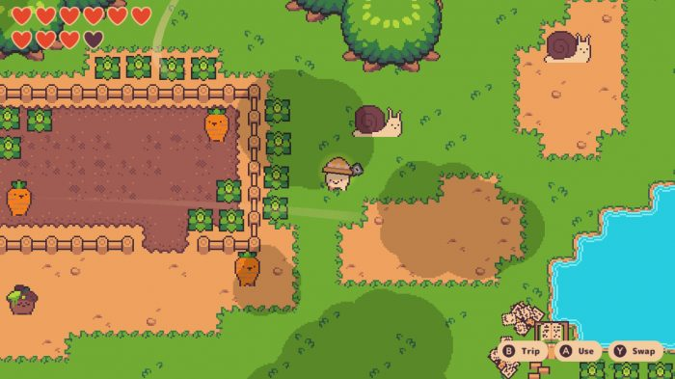
* Kakuriyo
  + How filled each room is
  + Creepy but cute vibes
  + 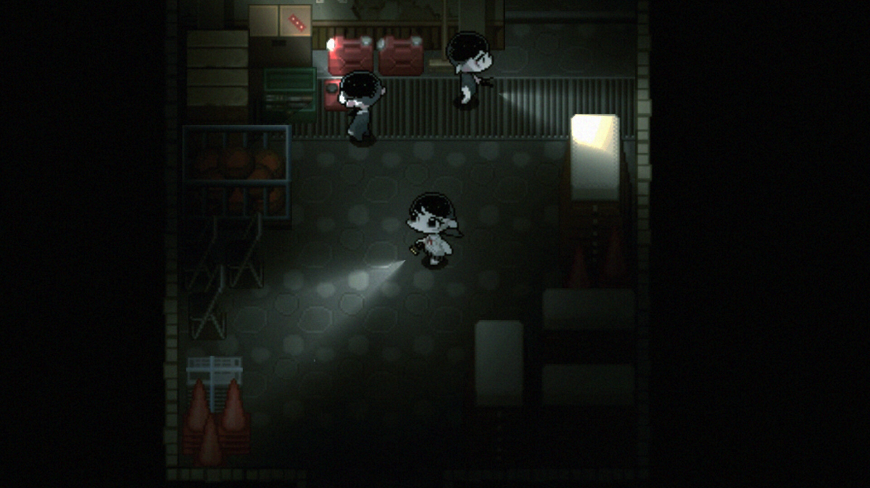
* Corpse Party
  + Sprites and rooms have enough details to differentiate each one
  + (If we have time) each pixel sprite has its own fully illustrated image during dialogue scenes
  + 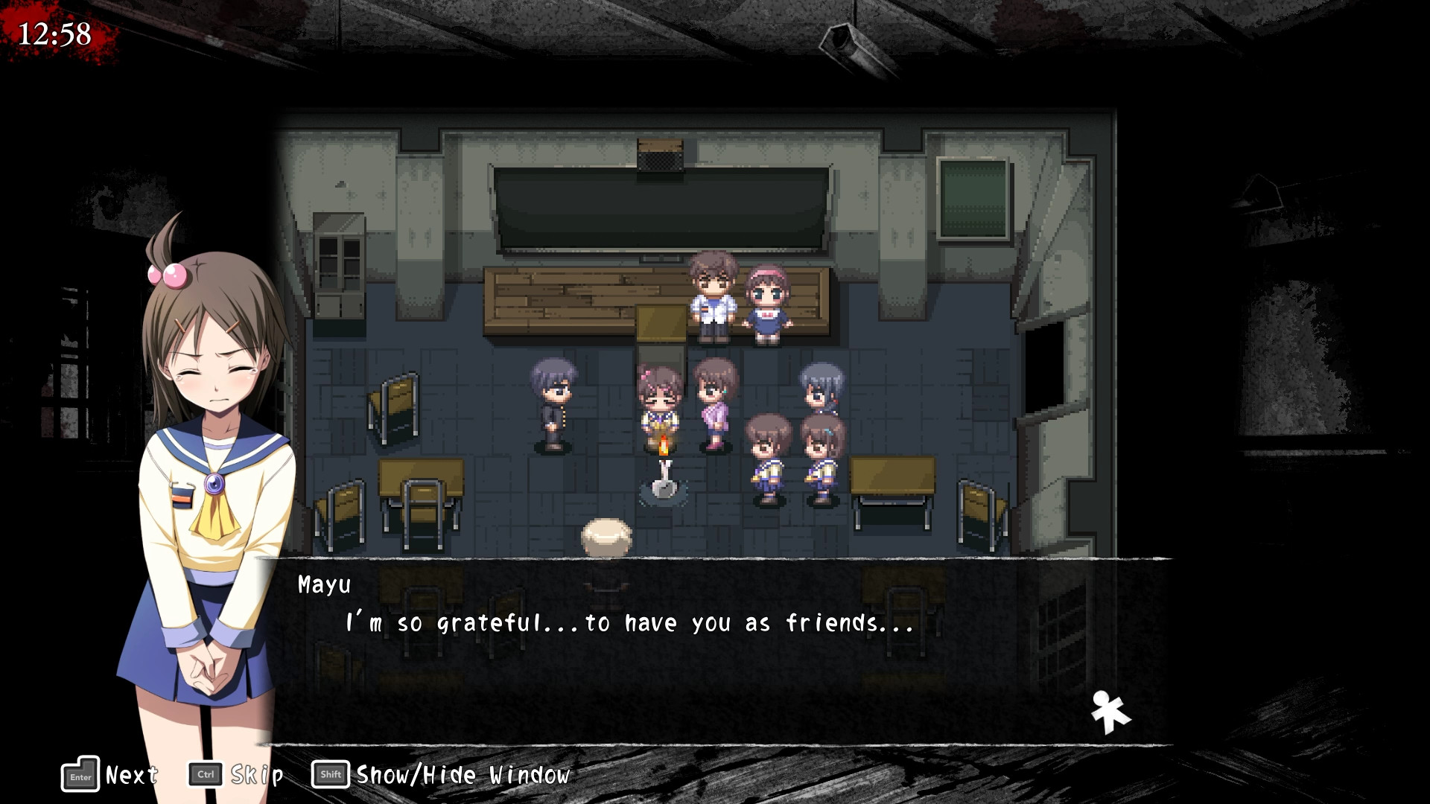
  + 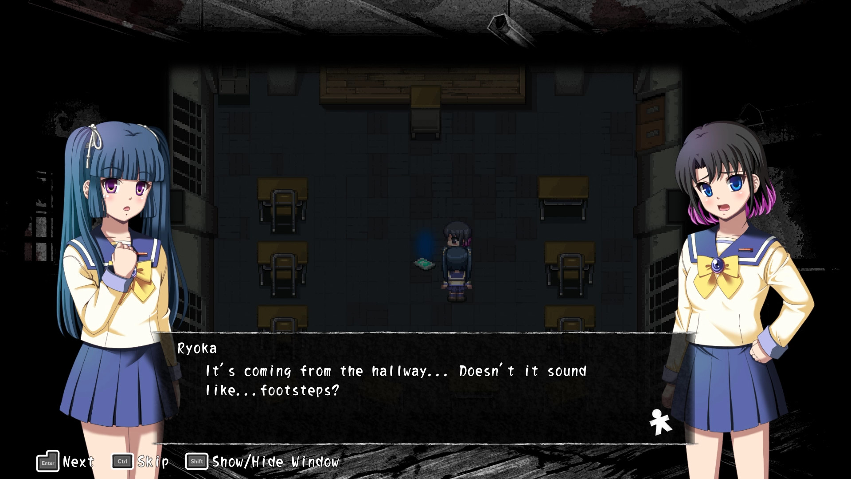
  + 16-bit
* Gameboy Legend of Zelda games
  + We can add more details even though it's pixel art -> would require a bigger pixel canvas
  + 